CURRICULUM VITAE
Luciene Sant’Anna Takagi, Psy.D., LLC

Curriculum Vitae Lucy Takagi, Psy.D.

Home: 155 Eileen Dr. Cel. (973) 979-7987
Cedar Grove
New Jersey, 07009 Email: lucytakagi@yahoo.com
Dr.lucy.takagi@gmail.com
takagil@mail.montclair.edu
_________________________________________________________

EDUCATIONAL BACKGROUND
2014: Completed Child First/ Finding Words- New Jersey Update Training

2008-2009: Completed the 1-year Training of NJ-Child Sexual Abuse Case Consultation Project at the Audrey Hepburn Children’s House

2008: Completed the 5-days training for Child First/ Finding Words-New Jersey Forensic Interviewing Protocol

1999 - 2006: Graduate School of Applied and Professional Psychology GSAPP – Rutgers University, New Brunswick, NJ. Clinical PsyD degree.

1996 – 1999: Montclair State University (M.S.U.), Montclair, NJ. M.A. in Educational
Psychology with a concentration in Child and Adolescent Clinical
Psychology.

1994 – 1996: Montclair State University, Montclair, NJ. Undergraduate Psychology
classes.

1983 – 1987: University of Rio de Janeiro (UniRio), Botafogo, Rio de Janeiro, Brazil.
B.A. in Theater Arts, Major in Acting.

1982: Gama Filho University Medical School. First year of Pre - Med classes.

1979 – 1981: Federal Technical School of Chemistry. Chemistry Technician and High School degrees.

LICENSES:

12/16/2021 – PsyPact APIT Number: 10021 APIT Issue Date: 12/16/2021

2021 (March) – Florida Telehealth Provider Registration # 751

2020 (May) – Maine Emergency Temporary License

2012 – Psychologist in New Jersey, NJ Lic # 35SI00493600

2011 – Psychologist in New York State, NYS Lic # 19014-1

2018 – Temporary License in Texas

2020 – Emergency Temporary License in Maine during COVID19 as of March 13, 2020. Expires 60 days from the conclusion of the State of Civil Emergency declared by Governor Mills.

HONORS
2022: “NJPA Psychologist of the Year” Award. Presented at the NJPA Fall Conference on October 21, 2022 at the Pines Manor in Edison, NJ.

2021: “2021 Outstanding Psychologist Award” in a State, Provincial or Territorial Psychological Association given by the American Psychological Association Division 31.

12/2020: Proclamation by the Officers of the New Jersey Psychological Association (NJPA) in recognition of the outstanding work as President of the Association during the pandemic and quarantine of 2020.

2018: Nominated for the NJPA Psychologist of the Year Award for advocacy work regarding the exclusion of psychodynamic psychotherapy interventions as recommended interventions in the APA’s Post-Traumatic Stress Disorder Clinical Practice Guidelines.

2013: Received the Grace K. Smith Award for Meritorious Service for outstanding service to the Graduate School of Applied and Professional Psychology (GSAPP) Alumni Organization.

2006: Received the Robert Weitz Award for all the contributions to professional psychology while a student at the Graduate School of Applied and Professional Psychology at Rutgers University.

2003: Received the Dean’s Award for Contribution to the Professional Development of Students at the Graduate School of Applied and Professional Psychology at
Rutgers University.

2002: Received the Dean’s Award for Contribution to the Professional development of Students at the Graduate School of Applied and Professional Psychology at Rutgers University.

2001: Received the Dean’s Award for Contribution to the Professional Development of Students at the Graduate School of Applied and Professional Psychology at Rutgers University.

1999: Received the 1999 Outstanding Graduate Student Award at Montclair State University (MSU). Nominated for Graduate Student Speaker at 1999 MSU Commencement.

1997: Certificate of Appreciation by the Dean of Graduate Studies, Carla Narrett,
Ph.D., at M.S.U for outstanding dedication.

1996: Psi Chi, M.S.U.

CLINICAL EXPERIENCE

August 2021 – Present: Psychologist in Private Practice at Luciene Sant’Anna Takagi, Psy.D., LLC at Essex Suites – 25 Pompton Ave, Suite 302, Verona, New Jersey, 07044, providing psychotherapy to adults with a variety of clinical problems.

August 2014 – Present: Psychologist in Private Practice at Luciene Sant’Anna Takagi, Psy.D., LLC at 78 Fillmore Street, Newark, NJ 07105, providing psychotherapy to adults with a variety of clinical problems, and Psychological Evaluations for undocumented Portuguese-speaking immigrants, seeking documentation.

May 2012 – September 2017: Psychologist in Private Practice at “Affiliates in Psychology and Education” at 882-A1 Pompton Ave, Cedar Grove, New Jersey.

November 2007 to November, 2009: Psychologist Position at the Audrey Hepburn Children’s House (AHCH) at Hackensack University Medical Center (HUMC).

- Conducted two psychosocial forensic evaluations a week assessing victims of childhood abuse (physical and sexual) and/ or neglect. Also conducted forensic evaluation of parents charged with abuse and/ or neglect and assessed their capacity to protect and parent appropriately.
- Conducted psychotherapy with an average of twelve cases per week, where abuse and or neglect had been substantiated.
- Submitted written Psychosocial Evaluations and Therapy Summary reports weekly to DYFS and/ or to the Prosecutor’s Office.
- Attended weekly individual supervision and group meetings.
- Participated in meetings with DYFS (Division of Youth and Family Services) caseworkers and supervisors, clinicians, case advocates and lawyers with the goal of maximizing case coordination and treatment goals.
- Managed an average of two team evaluations per month, requiring the overall management and coordination of the case, as well as the delivery of a final report on a timely fashion.
- Provided crisis intervention and management as needed from a clinical and evaluative perspective.
- Participated in Sexual Abuse Case Consultation Seminar Group meetings twice a month.

June 2007 to October 2007: Clinical Coordinator of the Barnert Hospital Child and Adolescent Unit.

- In addition to the clinical duties described under the Post-Doctoral position (see below), was responsible to screen all clinical cases and to assign them to clinical staff; to manage staff productivity and clinical needs; to educate and prepare staff for JCAHO visit (Joint Commission of Accreditation of Health Organizations); to administratively supervise staff and to clinically assess and provide crisis management as needed; to inform staff of administrative needs and to mediate communication between staff and administration in the hospital. In view of the abrupt closing of Barnert Hospital, responsibilities also included supporting staff during a difficult transition period as well as preparing staff and clients for termination issues.

February 2007 to June 2007: Post-Doctoral Clinical Position at Barnert Hospital in
Paterson, NJ.

- Conducted individual, couple and family psychotherapy with a culturally diverse inner-city population.
- Conducted bi-weekly group psychotherapy with parents mandated by DYFS and by the Court to parenting classes.
- Conducted bi-weekly group psychotherapy with adolescent sex-offenders.
- Attended weekly meetings and supervision.

Fall 2005 to Fall 2006: Internship at Trinitas Hospital, Elizabeth, NJ.

- Completed a six-month rotation at the Acute Adult Partial Hospital, conducting a daily Interpersonal Group with all the English-speaking patients in the Program, conducting individual psychotherapy and discharge planning with an average of three Partial patients per month, participating in crisis intervention and risk assessment when necessary, participating and discussing treatment and clinical issues in team and staff meetings. Rotation Clinical Supervisor: Henry Janc, PhD.
- Conducted Individual and Family Outpatient Psychotherapy with an average of six cases per month in the Child/Adolescent (C/A) Outpatient unit at the hospital throughout the year. Conducted two intakes per month in the unit. C/A Clinical Supervisor: Lucille Carr-Kaffashan, PhD.
- Conducted Individual and Family Psychotherapy with an average of seven patients per month in the Adult Outpatient unit.
- Conducted two intakes per month in the unit. Clinical Supervisor: Tom Johnson, EdD.
- Conducted eight Psychological Test Batteries. Testing Supervisor: Nicole Livingston, PhD and Lucille Esralew, PhD.
- Under the Wellness Consultation rotation, helped implement the “Success Skill Training Program” at Central Five School in Union,NJ through weekly individual meeting with at risk students and teachers, classroom coaching, implementing behavioral modification techniques and providing occasional presentations to educate teachers about relevant topics of interest (i.e. stress management, classroom management, etc).
- From June to September 2006 worked at Lubrizol Corporation in Linden, NJ, providing executive coaching, seminars and individual sessions for employees coping with company closing, unemployment, developmental, health and stress-related issues.

Spring 2000 to Fall 2004: Clinician at the GSAPP Psychological Clinic, Rutgers
University.

- Conducted psychotherapy with individuals and with couples.
- Conducted over one hundred intake interviews. Presenting issues treated ranged from mood, anxiety, and adjustment disorders to suicidal attempts, personality disorders and bereavement related to September 11.
- Clinical supervisors: Donald Morgan, PsyD; Duncan Walton, PhD; Carole Salvador, PsyD; Timothy O’Connel, PhD; Joan Morgan, PsyD and Susan Herman, PhD.
- As a GSAPP Clinic coordinator I also had some evaluation experience under the clinical supervision of Douglas Haymaker, PhD and Donald Morgan, PsyD.

Fall 2002 to Spring 2003: Invited to coordinate and co-supervise GSAPP.COM - a peer
mediated bi-weekly group meetings - to facilitate the adjustment of new, incoming students to the GSAPP community - with Lew Gantwerk, PsyD.

Fall 2001 to Spring 2003: Clinic Coordinator at the GSAPP Psychological Clinic,

Rutgers University.

Experience included psychological screenings done prior to assigning cases to clinicians.

Updating the Clinic’s database

Assigning cases to student clinicians

Setting up a referral system and making referrals as needed

Selecting specific clients assigned to applied courses

Training student clinicians for clinical and clinic duties

Database entry

Conducting crisis intervention when necessary.

Fall 2000 to Spring 2001: Externship at Newark Beth Israel Hospital, Newark, NJ.

Experience included forensic assessments and treatment of children and families with allegations of sexual and/or physical abuse and/ or neglect.

Created, organized and co-led a process therapy group for mothers who had a history of sexual abuse and who had children who had been abused.

Supervisors: Olivia Lewis-Chang, PsyD and Susan Buckley, PsyD.

Fall 1999 to Spring 2000: Externship at Rutgers Counseling Center at College

Avenue, New Brunswick, NJ.

Conducted individual psychotherapy with undergraduate and graduate students.

Participated and led outreach programs.
- Presented clinical cases to senior staff during staff meetings

Supervisors: Mark Forest, PhD; James Mandala, PhD; Anne McEneaney PhD; Kathy Straton, PsyD.

Fall 1998 to Spring 1999: Volunteer at Essex County Hospital in Cedar Grove – a
County facility that provides psychological and psychiatric treatment for an in-patient population with severe psychopathology.

- Co-led inpatient activity groups with Barbara Alter, PhD and John Schmerler, PhD.
- Participated as a student facilitator in weekly MICA groups.

Fall 1998 to Spring 1999: Extern at the Montclair State University Center for Psychological Services where conducted individual psychotherapy and intakes of MSU students in need of services.

ADMINISTRATIVE/ LEADERSHIP EXPERIENCE

September 2023 to December 2023 – Affiliate Member of the United Nations (UN) Society for the Psychological Study of Social Issues (SPSSI). Participated in the Psychology Coalition (PCUN) meetings, attended meetings and served as rapporteur for the “Peace, Human Security and Sustainability of People and the Planet” conference on 09/07/23 hosted and organized by the Conference of NGOs (CoNGO) at the United Nations.

January 2021 to December 2021 – Past President of the New Jersey Psychological Association.

January 2020 to December 2020 – President of the New Jersey Psychological Association (NJPA). Accomplishments included:
- Leading the selection and hiring of the NJPA Director of Professional Affairs (DPA)
- Addressing members frustration regarding an RxP survey distributed in the Fall, 2019, by creating a History of RxP in NJPA document, distributed to all members informed by Past NJPA Presidents reports.
- Appointed a Task Force and a Chair to address the RxP issue through a Future Search informed town-hall meeting for all members to participate.
- Managed the COVID19 pandemic by writing and distributing Executive Board approved letters to the NJ Governor & NJ Legislators, the Department of Banking and Insurance (DOBI), Senators Corey Booker and Senator Robert Menendez, addressing: inconsistencies with insurance reimbursement and coding, need for coverage for audio-only psychotherapy sessions, interjurisdictional challenges, psychology students and early-career needs as well as requests for governmental officials to not only measure the demographics of COVID positive patients, but also the possible disparate impact of COVID-related legislations and policies on members of marginalized groups.
- In March 2020, NJPA issued a statement condemning acts of xenophobia and racism in view of the coronavirus and on March 6, 2020, Lucy S. Takagi wrote a letter to the NJ Governor Phil Murphy, with the approval of the NJPA Executive Board titled: “Compassionate Communities – A NJPA Call for Attention to Marginalized Groups” stating: "It is with the goal of compassion in mind, that we, as psychologists, recognize how the mental and physical health of citizens from marginalized groups can be impacted by measures that may not take their specific needs into account." Lucy Sant' Anna Takagi, PsyD, NJPA President.
- Introduced and received Board endorsement for a NYS Psychological Association letter advocating for APA and APPIC to prorate the required annual clinical hours for students, permit holders and post-doctoral professionals, to 85% in view of the impact of the pandemic (e.g. proposing that 15% of the regular required clinical hours be dismissed for 2020).
- Direct communication with and responses from the Department Of Banking and Insurance (DOBI) regarding reimbursement problems with Horizon Blue Cross & Blue Shields for March 2020.
- Supported the NJPA Committee on CE Accreditation on renewing their accreditation with the American Psychological Association and with developing a library of Virtual and Lives CE credit presentations for members to complete their CE requirements.
- Revived the NJPA Publications Committee by appointing a new Chair, by supporting the committee’s recommendations with the Executive Board and by supporting the recommendation of an electronic-only journal.
- Met weekly with the NJPA Executive Director and Treasurer during the COVI-19 pandemic to address and oversee the NJPA Budget.
- Appointed the then President-Elect Daniel Lee, PhD to lead a “The Power of the Spoken Word” podcast series distributed to members of the Association.
- Participated in bi-monthly meetings with the New Jersey Inter-Mental Health and Psychological Associations Coalition (IMPAC), a group including leaders of NJPA, the NJ Chapter Association of Black Psychologists (NJABPsi) and the Latino Mental Health Association of NJ (LMHANJ).
- IMPAC developed its first virtual conference titled: “One Scar, Too Many: Addressing the Mental Health Needs of Undocumented Immigrants in the Face of Trauma” presented by Luz M. Garcini, PhD, MPH, on June 5, 2020.
- On June 20, 2020 NJPA hosted Opioid Addiction and Its Treatment: A Guide for Practicing Psychologists presented by Arnold Washton, PhD. This virtual program had 48 attendees. On June 26, 2020, NJPA hosted Reframing the Experience of African American Women’s Mental Health: The Intersection Between Race, Culture, and Gender and Its Impact on Psychological Well-Being presented by Angela Clack, PsyD, LPC. This program ha 35 attendees. In October, 2020, NJPA hosted “Adverse Childhood Experiences (ACEs): Context and Consequences” presented by Susan Cohen Esquilin, PhD, ASPPB.
- Recorded and disseminated multiple videos updating members on NJPA-relevant issues.
- Worked closely with NJPA’s Executive Director throughout the year, as well as with NJPA staff.
- Coordinated two first-time virtual annual NJPA conferences (Spring and Fall).
- Developed a first time NJPA Virtual Conference in collaboration with the Montclair State University on Maternal Health on September 25, 2020 titled: “Access to Care and Maternal Health Disparities across the New Jersey Landscape.”
- Encouraged collaboration between NJPA and its Affiliate Organizations by coordinating invitations of legislators to Affiliate events (e.g. on September, 2020, Assemblywoman Nancy Muñoz participated in a EUCAP/NJPA meeting and in 2020, Assemblywoman Mila Jacey also participated in an EUCAP meeting)
- Testified on behalf of A-543/S-2552 (amends the training requirements for psychologists) which Governor Murphy signed into law on December 2020; for S-2556 (Telehealth) which Governor Murphy conditionally vetoed in 2021; and advocated for A-5205/ S-2506 (Enters NJ into Psychology Interjurisdictional Compact/ PSYPACT) which Governor Murphy signed into law in 2021
- Presided over multiple letters written to the NJ Governor and Legislators, as well as to Senators Cory Booker and Robert Menendez, advocating for the needs of psychologists in NJ during the COVID-19 Pandemic.
- See Legislative Experience below.

March 2019 – Elected Member at Large (MAL) of the American Psychological Association (APA) Committee of State Leaders (CSL). Member of two CSL subcommittees: Advocacy and Mentoring Subcommittee in 2019; and of the Leadership & Networking Subcommittee and Diversity Subcommittee for 2020.

January 2019 – December 2019 – President-Elect of the New Jersey Psychological Association (NJPA). As such, member of the NJPA Leadership Team, Member of the NJPA Governance Committee, Member of the NJPA Foundation Committee, Member of the NJPA Committee on Diversity and Inclusion (CODI), member of the NJPA Membership Committee, Member of the NJPA Finance Committee, appointed Member of the NJPA Committee of Legislative Affairs (COLA), appointed Member of the NJPA Geographic Diversity Task Force, Member of the NJPA Immigration and Emergency Action Group, and Member of the NJPA May as Mental Health Month Committee.

January 2019 – Past-President of the Essex and Union County Association of Psychologists (EUCAP).

January – December 2018 – Appointed as Member of the NJPA Membership Committee, The May as Mental Health Month Committee, the Finance Committee, and Chair of the ECP Planning Group

June 2018 – Invited as a leading group member of lawyers, mental health workers and child advocates to visit Casa Padre, a federal detention center in Brownsville, Texas, to interview and assess the needs of over 1,000 undocumented minors separated from their families under the “Zero Tolerance” policy and detained.

January 2018 – Elected Member at Large (MAL) of the NJ Psychological Association Executive Board.

December, 2017 – Crafted a Letter edited by five other psychologists (Jeannine Zoppi, Mark Siegert, Jeff Axelbank, Nancie Senet and Madelyn Milchman), to the NJPA Executive Board, requesting advocacy regarding the newly approved APA PTSD Clinical Guidelines. The six psychologists advocated with other APA Division, associations and members, and became known as the NJ6. The movement led to the formation of a national Alliance and the endorsement of a petition by almost 50,000 signatures.

Winter 2017 – Appointed as Chair of the NJPA ECP Committee Planning Group between December 2017 and June 30, 2018.

Fall 2017 – Appointed to NJPA Membership Committee Member

Fall 2017 – Elected Member-at-Large of the Executive Board of the New Jersey
Psychological Association (NJPA). Term will be served from Jan 2018 to December 2020.

Summer 2017 – Appointed to the NJPA Listserv Committee Structure Task Force.
- The focus of the task force was to review the structure of the NJPA Members Only Listserv governance and to determine if a new structure (e.g., using a Listserv Monitor Committee instead of just one or two people with the responsibility) and new rules will be proposed to the Executive Board. This Task Force gathered advice from both APAPO’s legal staff and NJPA’s legal consultants.

Spring 2017 – Appointed as Co-Chair of the NJPA Early Career Psychologists
Presidential Task Force.
- The mission of this Task Force was to ascertain Early Career Psychologists' needs and how NJPA could address these needs, better integrate Early Career Psychologists into the association, and develop ways to foster leadership development among Early Career Psychologists. The focus of the Task Force was to create a welcoming environment for these valued members.

Spring 2017 – Appointed a member of the NJPA Community Task Force –
- The mission of this task force was to present a recommendation to the NJPA Executive Board, encompassing a promotional statement that would directly acknowledge the bipartisan widespread psychological reactions to the political climate that psychologists are uniquely positioned to address. The statement promoted NJPA and its members as resources to individual consumers and community groups/agencies. This task force also proposed ways in which NJPA members could be of service to the New Jersey communities, including but not limited to our NJPA referral service.

January 2017-Present – President of the Essex and Union County Association of
Psychologists (EUCAP) in NJ.

Fall 2016 – President Elect for 2018/ 2019 of the Essex and Union County Association
of Psychologist (EUCAP) in New Jersey.

Fall 2016 – Nominated for Member at Large for the New Jersey Psychological
Association Executive Board.

Fall 2015 – Present:
- Invited member at large to the Essex and Union County Association of Psychologist (EUCAP) Board.

Spring 2017:
- Member of the NJPA Committee on Diversity and Inclusion (CODI)

Fall 2015 – Winter 2016:
- Secretary of the NJPA Committee on Diversity and Inclusion (CODI)

Spring 2015 – Summer 2015:
- Invited member by the NJPA Executive Board to be a member of the
Conversation on Diversity and Inclusion advisory meeting group.

Fall 2012 – Spring 2017:
- Early Career Psychologist Member of the New Jersey Psychological Association Ethics Committee.

Spring 2011- Present: Past- President of the GSAPP Alumni Organization.

- As Past-President of the GSAPP AO, Dr. Takagi helped coordinate along with Susan Spieler, PsyD various clinical case presentations for GSAPP alumni in NYC.
- On September, 2012, Dr. Takagi supported a clinical presentation by Michelle Bell, PsyD commented by Susan Spieler, PsyD.
- On January, 2011, Dr. Takagi presented a clinical case with commentaries by Seth Warren, PsyD.
- In 2010 Dr. Takagi helped coordinate and implement the first clinical case presentation for GSAPP alumni in NYC. A case on the integration of psychodynamic therapy and Somatic Experience therapy was conducted and presented by Claire Haiman, Psy.D. and commented by Susan Spieler, Psy.D. The case was presented in NYC on March, 2011.

January 2009- December 2010: President of the GSAPP Alumni Organization at
GSAPP, Rutgers University.
- As President of the Graduate School of Applied and Professional Psychology (GSAPP) Alumni Organization (AO) Board at Rutgers University, Dr. Takagi implemented multiple important projects.
- Under Dr. Takagi's presidency, the GSAPP A.O. Board hosted two award events (one in 2009 and one in 2010). The visibility of the GSAPP AO has significantly increased as a result of Dr. Takagi's participation in meetings with the GSAPP Dean, faculty and students and of her advocacy for the implementation of programs and events.
- Under Dr. Takagi's presidency, the GSAPP AO has created and implemented a website Resource List for students and alumni.
- The AO has created, distributed and scored the Supervisory Forms and created a survey to gain feedback about supervision and events.
- Two prestigious alumni were nominated and selected to receive two distinguished Rutgers University Alumni Association (RUAA) awards (Bonnie Markham, PsyD. and Dianne Clarke-Kudless, PsyD).
- Dr. Takagi has also implemented the Alumni Database Directory and began to discuss with the Board the needs of early career psychologists, which led to her implementation of the Mentoring project between alumni and current students.
- She attempted to engage the RUAA (Rutgers University Alumni Association) in attending GSAPP events and in supporting the GSAPP AO in its event planning.
- Under Dr. Takagi’s leadership the GSAPP AO Bylaws began to be reviewed and updated.
- Additionally, Dr. Takagi participated in two alumni gatherings (in PA and NYC) with the GSAPP Dean and GSAPP Development Officer representing the GSAPP AO and helping strengthening the ties between GSAPP and the alumni.
- Committees from the Board have worked tirelessly to accomplish tasks with limited manpower and resources.

Spring 2007: Appointed as the Clinical Coordinator for the Child and Adolescent
Unit at Barnert Hospital in Paterson, NJ.

Fall 2004: Appointed by the Dean to be a member of the “Selection Committee” to
search for a new Assistant Dean for GSAPP at Rutgers University.

Fall 2000 to Fall 2004: Student Representative for the GSAPP Alumni Association.
Responsibilities included creating a liaison between the
organization and the student body, helping with the organization
of multiple Alumni-Student dinners, with the recruitment and
invitation of alumni to events, and with the organization of the
“Career Development Project”, a workshop aimed at addressing
professional development areas such as licensure and how to
setting up a business.

Fall 2000 to Spring 2003: Created, implemented and organized the “GSAPP
Presentation Series” at GSAPP – a colloquia series with a
total of over thirty professional psychologists as presenters
over the course of three years (e.g. Terry Wilson, Robert
Carter, Derald Wing Sue, Nancy McWilliams, Stanley Messer,
Jonathan Raffes, Milton Schwebel among others).

Fall 2000 to Spring 2001: Member of GSAPP Diversity Committee, a group
committed to discussing diversity issues at GSAPP, to voice
and to facilitate the needs of international students and to
increase the awareness of how diversity issues impact the
community.

Fall 1999 to Spring 2000: Co-Chair of the GSAPP Student Alliance, an organization
coordinated by students committed to address the needs of
students with faculty and administration, to enhance the
cohesion among the clinical, organizational and school
programs at GSAPP and to sponsor other student-led
committees.

1997: Appointed as the Graduate Student Representative for the Disciplinary Board,
Student Development and Campus Life Department at M.S.U., with Helen
Matusow-Ayres EdD (Dean of Students).

TEACHING EXPERIENCE

July 2013 to Present: Clinical Specialist at the Center for Child Advocacy and Policy at Montclair State University. Teaches eight face-to-face and/ or online courses a year (four courses in the Spring, three in the Fall and one Courses over the summer). Teaches, coordinates and supervises Practica placements and experiences for students in the Masters of Child Advocacy and Policy program. (*** A detailed description of the responsibilities involved in the coordination of these courses is available as an Addendum section of this Vitae, upon request)

Spring 2011 – June 2013: Assistant Professor at the Center for Child Advocacy at
Montclair State University. Teaching schedule includes
teaching 4 required and one optional (as needed) graduate
and undergraduate courses, such as Child Abuse and
Neglect; Selected Topics in Child Advocacy; Forensic
Interviewing; Introduction to Child Advocacy, etc.

Fall 2010 – Spring 2011: Adjunct Professor for Multicultural Supervision at the
Graduate School of Applied and Professional Psychology
(GSAPP) at Rutgers University in New Brunswick, NJ.

Spring 1999: Adjunct Professor for Educational Psychology at Montclair State
University (MSU) under the supervision of Mark J. Friedman, PhD.

Fall 1998: Adjunct Professor for Psychology of Adjustment at MSU under the
supervision of Mark J. Friedman, PhD.

Pre-Summer 1998: Adjunct Professor for Introductory Psychology at MSU under the
supervision of Mark J. Friedman, PhD.

1996 to 1998: Received a Graduate Teaching Assistantship at MSU. Duties included
Teaching and working with professors and graduate assistants, as well as
assigning and supervising Teacher-Assistants across a variety of courses.

Worked as a Graduate Teacher Assistant with Mark J. Friedman,
Ph.D.(Psychology I); Jerry Schwartz Ph.D.(Psychology I); Sandra Lewis
Ph.D.(Psychology II); Marguerita Garcia PhD (Quantitative Methods) and
Robert McCormick (Teaching of Psychology). Duties involved organizing
Reviews and Study Groups; individual tutoring; help with grading and
mediating student’s issues.

Appointed to substitute professors in the following courses: Psychology I (Mark J. Friedman Ph.D., Jerry Schwartz Ph.D., Martha Lequerica Ph.D.); Psychology II (Sandra Lewis Ph.D.); Quantitative Methods (Marguerita Garcia Ph.D.); Perception (Edward Haupt Ph.D.); Teaching of Psychology (Robert McCormick Ph.D.); Abnormal Psychology (Luis Montesinos Ph.D.).

1995 to 1996: Volunteered for assisting Marguerita Garcia Ph.D., at M.S.U. in
undergraduate Quantitative Methods for three consecutive semesters.
Responsibilities involved setting study groups, tutoring, grading exams
and assignments, and teaching as a substitute when needed.

LEGISLATIVE & LEGAL EXPERIENCE TESTIMONIES:

- 03/08/2021: Lucy Sant’Anna Takagi, PsyD, LLC testified to the NJ Assembly Health Subcommittee, Chaired by Assemblyman Conaway and Vice-Chaired by Assemblywoman Jimenez, requesting support for Assembly Bill 4205 which enters NJ into the Psychology Interjurisdictional Compact (PsyPact). Unanimously approved. Recording: Assembly Health Committee, A-4205 testimony begins at 20:44:
https://www.njleg.state.nj.us/media/mp.asp?M=V/2021/AHE/0308-1215PM-M0-1.mp4&S=2020

- 10/26/20: Lucy Sant’Anna Takagi joined APA CEO, Dr. Arthur Evans, at a legislative event for Education Director of The Kennedy Forum, Amy Kennedy and Congressional Representative, Frank Pallone. Dr. Takagi shared the importance of the continuation of telehealth exemptions as a result of covid, psychology, psychologists, NJPA, access to mental health care, and telehealth in New Jersey.
- 10/27/20: Dr. Lucy Sant'Anna Takagi testified at the Senate Health Committee Telehealth Meeting. The Committee heard testimony from members of the public concerning the provision of services using telemedicine and telehealth during the COVID-19 pandemic, including how those services are covered under health benefit plans, and the ways in which state law concerning the provision of services using telemedicine and telehealth may be revised or restructured on a permanent basis. (Listen to Dr. Lucy Sant/Anna Takagi starting at recording time 1:38:00)
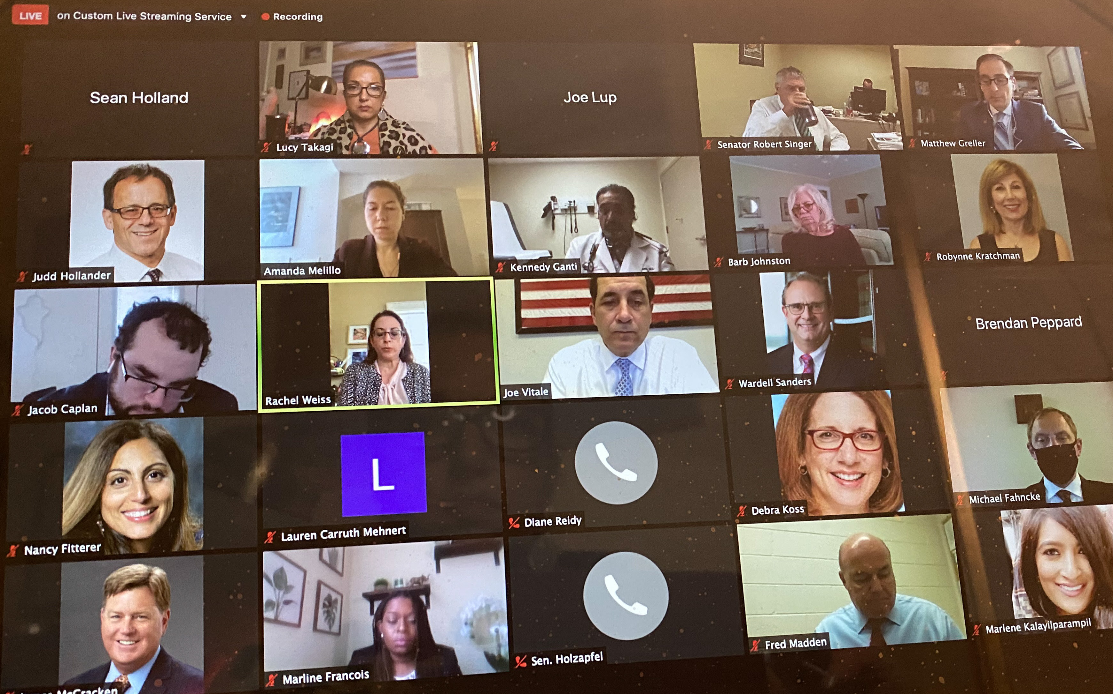

- 10/27/20: Dr. Takagi, NJPAGS representatives, Chelsea Torres, Dominique Reminick, Alex Gil, and Kristine Kroot, and other NJPA Leaders, were excited to learn that Congressman Payne was added as a cosponsor for H.R. 6720, the Student Loan Forgiveness for Frontline Health Workers Act, after a virtual Capitol Hill visit! NJPA’s visits with Senator Cory Booker, Senator Robert Menendez, and Representative Donald Payne’s offices were scheduled to address the need to strengthen federal support for psychology students and trainees during COVID-19 by: cosponsoring and passing H.R. 7761, the Protecting Access to Loan Forgiveness for Public Servants During the COVID-19 Pandemic Act; cosponsoring and passing H.R. 6720, the Student Loan Forgiveness for Frontline Health Workers Act; and cosponsoring and passing H.R.7449/S. 4141, the Bank on Students Coronavirus Emergency Loan Refinancing Act.
- 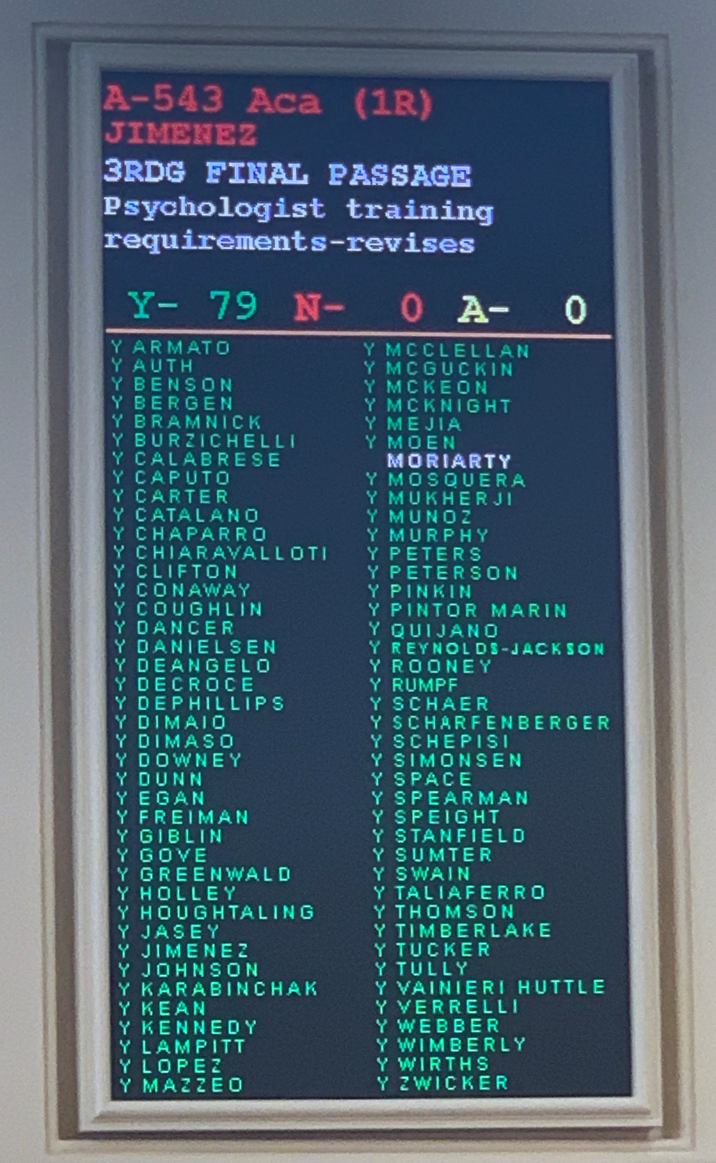
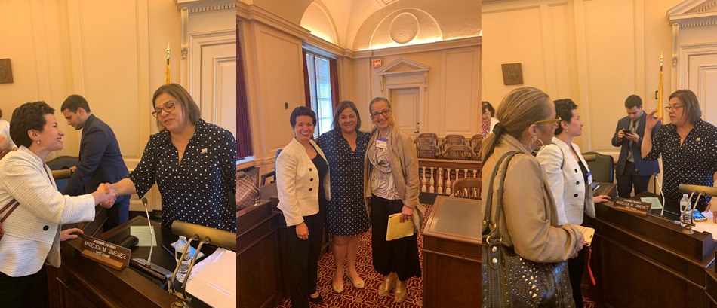

- In 2019 - NJPA President, Lucy Takagi, PsyD, then NJPA president-elect, and Michelle Pievsky, PhD, then NJPA Early Career Psychologist Committee chair, testify at the June 6, 2019 Assembly Regulated Professions Committee hearing for the NJ Licensing Act Legislation – A5307 (2018-2019 bill number) Revises psychologist training requirements. They are seen with Primary Sponsor Assemblywoman Angelica M.Jimenez. Click here to listen.

This proposed legislation will allow many early career psychologists (ECPs) who have already received over 3500 hours of supervised clinical training to become licensed sooner. ECPs in NJ struggle to find appropriate post-doctoral placements, supervision, and compensation, and this bill would support their ability to be reimbursed for any postdoctoral training they still may choose to pursue. This bill will help ECPs pay back their student loans, support themselves financially, and work more than the 20 hours a week permitted to permit holders. It will encourage them to remain in NJ, instead of moving to states with more flexible licensure requirements, like NY and PA, and increase the number of mental health providers in NJ who provide services to those who need them most.

- Testimonies for A543/S2582 - Revises psychologist training requirements.
A543 (Jimenez/Giblin/Vainieri Huttle), which amends the training requirements for psychologists, passed the Assembly Regulated Professions Committee on Monday, January 27, 2020 by a vote of 6-0. Dr. Lucy Takagi, NJPA President, testified on Monday, January 27, 2020! On February 24, 2020, it passed the full Assembly.

- On June 15, 2020, an identical bill (S2582) was introduced in the Senate by Senate Primary Sponsor Vin Gopal. On July 23, 2020, at 1:00 pm this bill passed the Senate Commerce Committee by a vote of 5-0. The legislation went to the Senate for final passage.
- 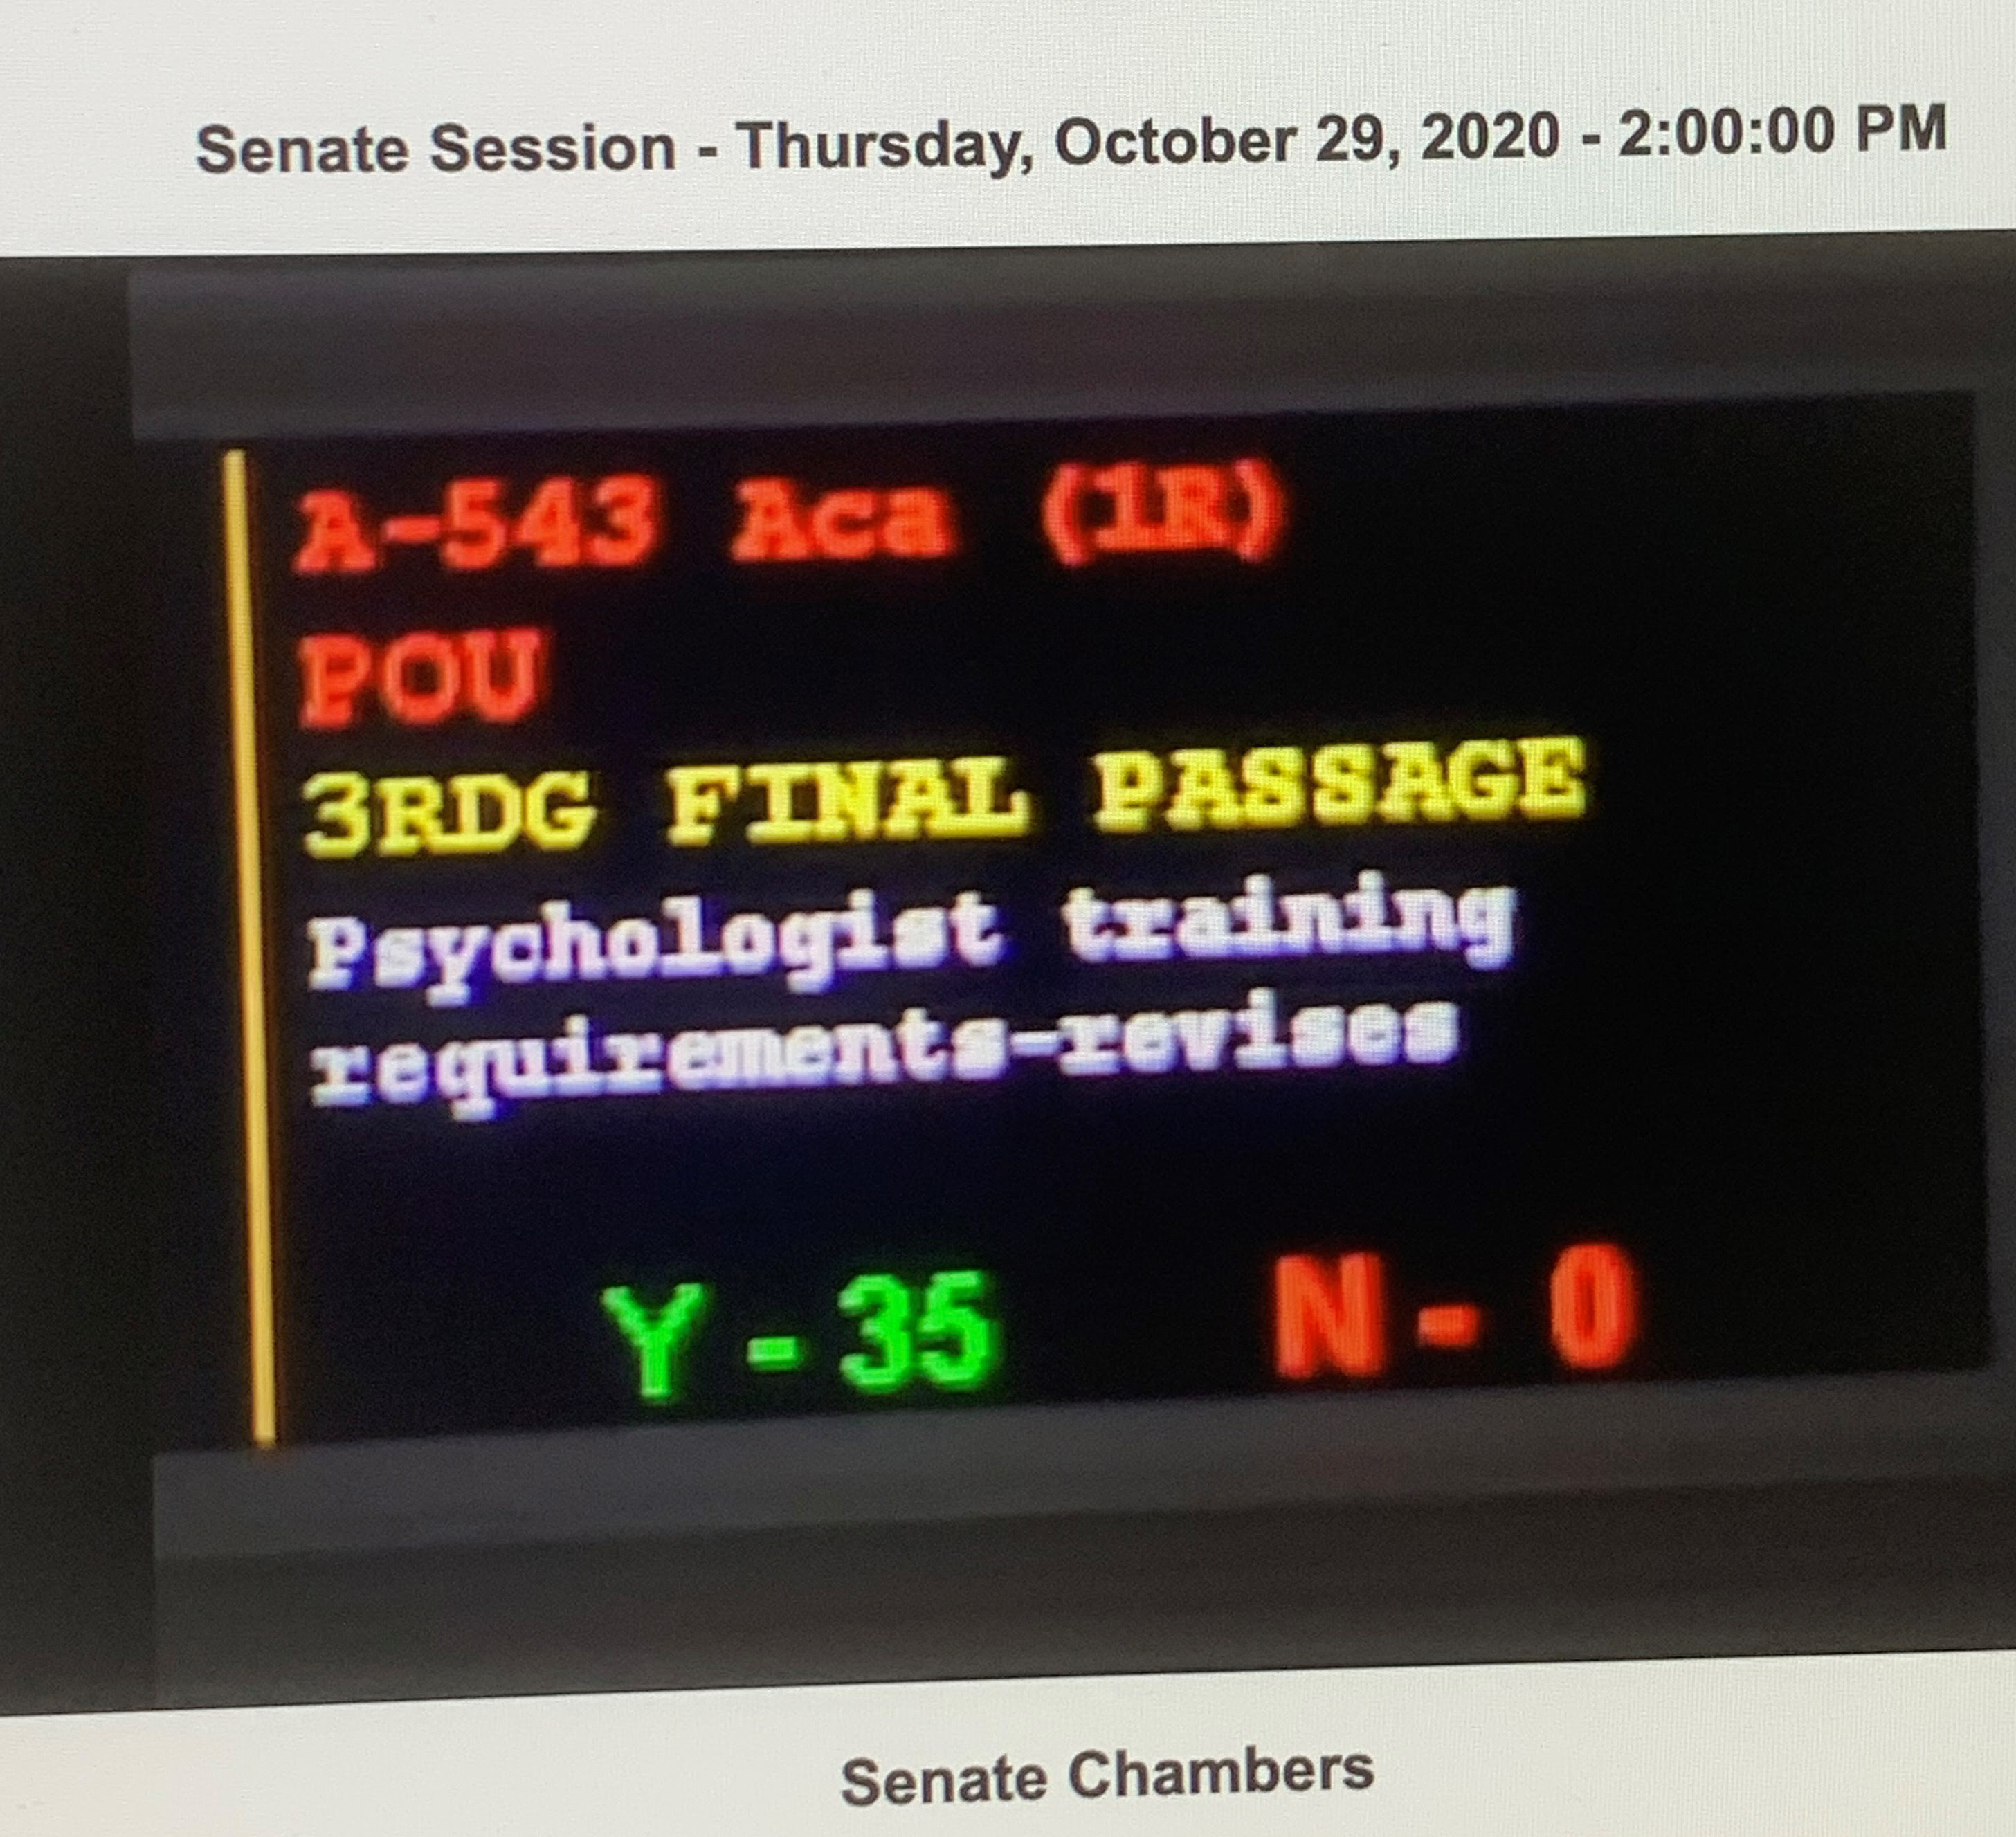

- 10/28/20: NJPA’s Bill A543/S2582, which updates the training requirements for psychologists (Dr. Takagi has been a leader of this initiative and has testified in the NJ Assembly for this Bill) passed the Senate by a vote of 35-0. NJPA’s Bill A543/S2582, was signed by Governor Phil Murphy on December 2020.
- 10/29/20: Dr. Lucy Sant'Anna Takagi and Keira Boertzel-Smith represented NJPA at Assemblywoman Huttle’s virtual legislative event. They discussed psychology, psychologists, NJPA, access to care, and telehealth in NJ. Assemblywoman Huttle was the NJPA 2018 Legislator of the Year.

Summer 2011; 2009; 2007: Testified as fact and expert witness on Family Court Cases,
and on Michaels Hearing.

PUBLICATIONS & ON THE NEWS

October 3, 2022: MSU “In the Know” Newsletter: Kudos to Lucy Sant’Anna Takagi Named
Psychologist of the Year by the New Jersey Psychological Association: https://www.montclair.edu/chss/2022/09/30/lucy-santanna-takagi-named-psychologist-of-the-year/?

September 30, 2022. MSU College of Humanities and Social Sciences News and

Announcements: Lucy Sant’Anna Takagi Named Psychologist of the Year: https://www.montclair.edu/chss/2022/09/30/lucy-santanna-takagi-named-psychologist-of-the-year/?wp_logged_in=true

Takagi, L. (2020). Reflections on COVID19: What is my life? Where is my life going? New
Jersey Psychologist, 70 (2), Fall 2020, p. 2. Retrieved from: file:///Users/lucyTakagi/Downloads/37960%20Fall%202020final.pdf

Advocating for Patients’ Growing Needs. New Jersey Monthly, by Shea Swenson,
September 2020, page 43. Retrieved on http://digital.njmonthly.com/njmonthly/september_2020/?pg=43&pm=2&u1=friend

Pandemic, social unrest increase need for therapists of color, accentuate shortage. By
Jane Havsy. Published on the Morristown Daily Record on August 31, 2020 at 5:36AM. Retrieved on, https://www.dailyrecord.com/story/news/local/how-we-live/race/2020/08/31/coronavirus-pandemic-social-unrest-increase-need-therapists-color/3356621001/

'Someone I could relate to': COVID-19, social unrest increase need for therapists of color.

By Jane Havsy. Published on USA Today on September 2, 2020 at 3:45PM. Retrieved on, https://www.usatoday.com/story/life/2020/09/02/coronavirus-pandemic-social-unrest-increase-need-therapists-color/5695898002/

Pandemic, social unrest increase need for therapists of color. By Jane Havsy. Published
on the Montclair Times on September 6, 2020; pages 3A & 5A. Retrieved on https://montclairtimes-nj.newsmemory.com/

Takagi, L. S. & Eisenberg, K. (Fall,2017). Working with immigrants: The competencies

and challenges. New Jersey Psychologist, Fall 2017, p.

Takagi, L. S. & Eisenberg, K. (Fall,2016). Should you become the treating clinician of a

client who you evaluated? New Jersey Psychologist, p. 10-11

Takagi, L. S. (Winter, 2016). “Struggling with requests for dual relationships in a small

community. New Jersey Psychologist, p. 13-14.

TALKS

October 2, 2020: Radio Interview at Business Talk Radio Station: https://businesstalkradio1.com/lucy-santanna-takagi-10-02-20-clinical-psychologist-arthur/

June 2, 2017: “Working with Immigrants: Understanding the Internal and External Journey and Dispelling Myths” – a presentation at the New Jersey Psychological Association (NJPA)

April 13, 2017: “Working with Immigrants” – a presentation to the Allied Mental Health staff of Morristown Memorial Hospital

October 22, 2016: “Untying Cultural Knots: The Ethics of Diversity in Private Practice” –
Panel Presentation at the New Jersey Psychological Association (NJPA) Fall
Conference 2016; a collaboration between the NJPA Ethics and Education
Resource Committee and the Committee on Diversity and Inclusion.

January 29, 2016: “Ask the Ethics Committee: An Introduction to Positive Ethics. Panel
Presentation to EUCAP members.

Spring 2015: Presented with members of the NJPA Ethics Committee at Montclair State
University on Ethical Decision Making in Forensic Cases.

Summer 2013: Presented at the MSU OIT Summer Institute “Strategies for a 7 1/2
Weeks Online Course in the Online Child Advocacy MA Program.”

April, 2013: Presented a Clinical Case at the MSU National Child Advocacy Conference:
The Forgotten Child: Multidisciplinary Approaches to Child Neglect.
Presented: “The Case of Ana: The Lingering Effects of Child Neglect and Psychological Abuse into Adulthood”

January 2012: Presented a Clinical Case Presentation for the Alumni of the Graduate
School of Applied and Professional Psychology (GSAPP) in NYC. Case
Discussant: Seth Warren, Psy.D. Presentation Hostess and Coordinator:
Susan Spieler, Psy.D.

Spring 2011: Panel speaker at the Graduate School of Applied and Professional
Psychology at the Minority/ International Student Alumni Dinner. Topic
Discussed: “Working with inner-city populations and developing a
sexual abuse specialty”

Spring 2006: Grand-Rounds presentation at Trinitas Hospital in May, 31, 2006. Topic
discussed: “Clinical and cultural Issues relevant to the Brazilian
Culture living in the USA.”

Fall 2004: Member of a graduate student panel at LPANJ Conference, responsible for
discussing issues that affect Latino graduate students. Topic explored:
“Getting an education and educating others.”

Fall 2003: Invited to speak on “Implications of September 11 for Graduate Students”
at GSAPP, Rutgers University.

Spring 1999: Presenter at 1999 NJ NAFSA Conference at Ramapo College: “Creating

Effective Psychological Counseling Services on Campus for

International Students”.

Spring 1999: Discussion Co-leader in National Alcohol Screening Day Workshop,at
Montclair State University.

MEMBERSHIP AND OFFICES

Past-president NJPA (2021)

President NJPA (2020)

President-Elect NJPA (2019)

American Psychological Association Committee of State Leaders Member at Large (2019-2021)

American Psychological Association (2019 – 2021)

APA Member at Large NJPA (2018)

Past- President EUCAP Executive Board

Past Member at Large EUCAP Executive Board

Member of the NJ Coalition Against Human Trafficking

Early Career Psychologist member of the NJPA Ethics Committee

American Psychological Association Member from 2006 – 2017

American Psychological Association, APA - Student Member since 1998.

APA Division 39 (Psychoanalysis) – Student Member since 2001: member of the Multi-Cultural Division with Dolores Morris, PhD as president.

New Jersey Psychological Association – Student Member since 2000.

The Latino Psychological Association of New Jersey – Associate Member since 1999

CONFERENCES ATTENDED

April 22, 2021: Dr. Andrew Kolodny - One Year Later: The Opioid Epidemic During COVID-19. Webinar by the NJ Division of Consumer Affairs.

December 2, 2020: IMPAC Event: Positive Black Identity Development: Threats and Strategies to Support Children and Parents (1 CE)

November 12, 2020: Children in the Coercive Control Context: Recognizing Ongoing Patterns of Victimizing Coercively Controlling Behaviors and the Cumulative Effects of Surviving within the Coercive Control Context by Cynthia M. Lischick, PhD, LPC, DVS

May 3, 2020: Adverse Childhood Experiences (ACEs): Context and Consequences by Susan Esquilin, PhD, ABPPP

April 30, 2020: NJPA Spring Conference - Disaster News and the Media in an Age of Anxiety.. Keynote Speaker: Daniel P. Villiers, PhD; Panelists: Stacey Rice Dobrinsky, PhD, Omar Canosa, MD, Samantha Quigneaux, LMFT and Debra Roelke, PhD

September 20, 2019: An Emerging Framework for Healthcare: Opportunities for Psychologists by Arthur C. Evans Jr., PhD (APA CEO)

May 3, 2019: NJPA Spring Conference: Foundations and Innovations in the Treatment of Complex Posttraumatic Stress Disorders by Dr. Christine A. Courtois, PhD, ABPP

April 12, 2019: Shine a Light on Multicultural Mental Health Awareness in New Jersey. NJPA Conference with Dr. Caroline Clauss-Ehlers, Drs. Denise Johnson, Yolanda Hawkins-Rodgers, and Aileen Torres and Afternoon Panel Moderator Dr. Jennifer R Jones-Damis.

March 31, 2019: Getting Licensed in NJ by Stacie Shivers, PsyD – sponsored by the NJPA ECP Committee.

May, 2018: NJPA Spring Conference: Treating Opioids, Alcohol, and Other Drug
Problems in Psychotherapy Practice: Expanding your Clinical Skills and Service by Presenter: Arnold M. Washton, PhD

March 9: The Slave Next Door: What Psychologists in New Jersey Need to Know About
Human Trafficking. Presenter: Susan Neigher, PhD and Jennifer Amaya

February 8, 2018: Current Conceptualizations of Complex Trauma. Presenter: Monica
Indart, PsyD

January 21, 2018: Gender in the Contemporary Clinical Situation. Presenter: Sam
Semper, PhD.

December 1, 2017: Implementing Telepsychology in New Jersey. Presenters: : Deborah
Baker, JD; LeMin Chin, PhD; Peter Economou, PhD; Judith Glassgold,PsyD

November 3, 2017: NJPA Conference: Lenore Walker on Domestic Violence

April 30, 2017: "Being The Other in The Therapy Room: You or Me? A Muslim
Perspective,” featuring Tuba Tokgoz, Ph.D. and Amelia Noor-Oshiro – a presentation by the Northeast County Association of Psychologists

November 18, 2016: “Cultural Competency with Transgender and Gender Expansive
Youth and their Families” by Lauren Picciano, Psy.D. at the Gran Centurions in Clark, NJ. Sponsored by EUCAP.

October 22, 2016: “Intergenerational Transmission of Trauma in the Family” by Irit
Felsen, PhD at the New Jersey Psychological Association Fall Conference

January 22, 2016: “Sexual Addiction” Presentation by Dan Watters, PhD at NJPA
Central Office.

December 4, 2015: “Practice Check up: Are you in compliance?” Presentation
sponsored by NJPA by Charles Cooper, PhD Director of Professional Affairs by the North Carolina Psychological Association and by Sally R. Cameron, Executive Director of the North Carolina Psychological Association.

September 21, 2015: “Complete the Puzzle: Creating, Growing and Maintaining a
Successful Ethical Practice” 3.5 Credits – NJPA

Fall 2015: “Undoing Racism” at Montclair, NJ. 15 CE credits

Spring 2015: “Invisible No More” – Second Child Advocacy Center National Summit on
Child Abuse & Neglect in the State of New Jersey hosted by Winona’s House Child Advocacy Center at NJPAC

Fall 2014: Wednesday, November 12, 2014 at 12:00pm.
“An Overview of Mobile Response Services” – Webinar sponsored by the Family Support Centers of New Jersey a division of the Department of Children and Families

Spring 2014: First Child Advocacy Center National Summit on Child Abuse & Neglect in
the State of New Jersey hosted by Winona’s House Child Advocacy Center at NJPAC

Fall 2013: NJPA Fall Conference – Andrea Celenza, PhD on Sexual Boundaries
Violations: How do they happen?

Summer 2013: MSU Office of Information Technology Summer Institute – Workshop for
Online/ Hybrid Teaching and Learning

Spring 2013: Commercial Sexual Exploitation of Children
Conference on Human Trafficking in Atlantic City, NJ sponsored by the NJ Multidisciplinary Team Coordinators Association and NJ Children’s Alliance

Fall 2012:
New Jersey Psychological Association Fall Conference – Jonathan Shedler on the Effectiveness of Psychodynamic Therapy.

Summer 2012:
MSU Office of Information Technology (OIT) Summer Institute – Workshop for Online/ Hybrid Teaching and Learning
Fall 2011:
“Undoing Racism” at UMDNJ University Hospital, Newark, NJ

Fall 2011:
Montclair State University – A Conversation with Salvador Minuchin on “The Craft of Family Therapy” and “The Evolution of Working with Families: Multiple Identities.”

Spring 2005:
APA Div 39 – Division of Psychoanalysis “Being and Becoming: 25 Years of Continuity and Change in Psychoanalytic Psychology.”

Otto Kernberg on “A Conversation with Otto Kernberg” at IPPNJ

Spring 2003:
Winter Roundtable, Columbia University, NY

Spring 2002:

Karen Maroda on “Seduction, Surrender and Transformation” at IPPNJ-NJ;
APA Div 39 – Division of Psychoanalysis “Evolving Domains”

Fall 2001:
Basic Training in Critical Incident Stress Management (CISM) for Crisis Workers
sponsored by NJPA.

Spring 2001:
Winter Roundtable, Columbia University, NY

Fall 2000:
Latino Psychological Association Conference Series

Spring 2000:
Winter Roundtable, Columbia University, NY;
XI International Forum of Psychoanalysis by the William Alanson White Institute;
Latino Psychological Association Conference Series

Fall 1999:
Clinical Psychology at the Turn of the Century, New York Beth Israel Hospital.

SPECIAL SKILLS

- Fluent in Portuguese and English (written and oral).
- Moderate understanding of Spanish but not enough to conduct psychotherapy.

PsyD Requirements:

Dissertation title: “An Exploratory Study of the Experience of Brazilian Female Immigrants Living in the USA”

Chair: Karen Riggs-Skean, PsyD and Nancy Boyd-Franklyn, PhD
Proposal accepted: Spring 2003
IRB Approval: Summer 2003
Data collected: Spring 2004
Defense: July 2005.

Internship Application: Fall 2004

Comprehensive Exams:
General COMPS – Passed: August 2001
Clinical COMPS – Passed: August 2003
Oral Comps – Passed: Spring 2006

Before 1987: Wide variety of courses and professional theatrical and television experience in Rio de Janeiro, Brazil

